- Stage- DSC Accepted
Plan- Max Life Smart Wealth Plan
THANOS
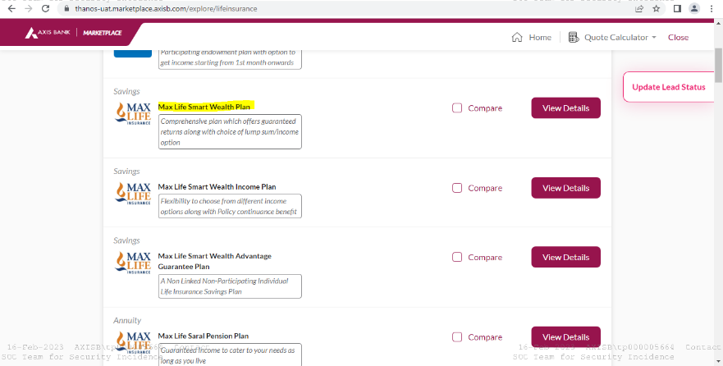
CRM
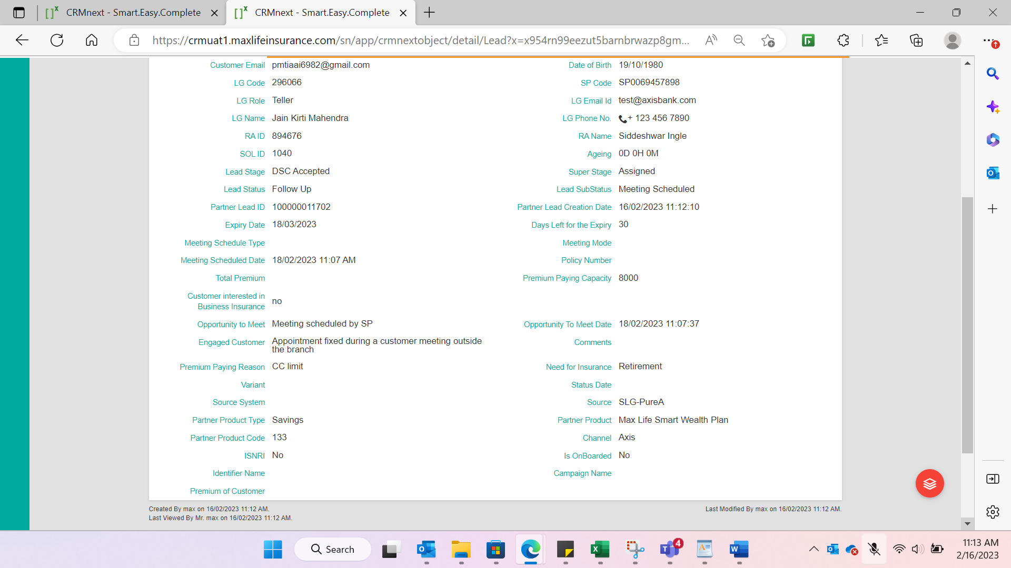
- On Stage- PSM Completed
Same Plan is reflecting on MLI CRM- Max Life Smart Wealth Plan
No disposition status update done by SP-RA

- Stage- Product Selection Completed
Changed product from Max Life Smart Wealth Plan to Max Life Saral Pension Plan
THANOS UI-SS

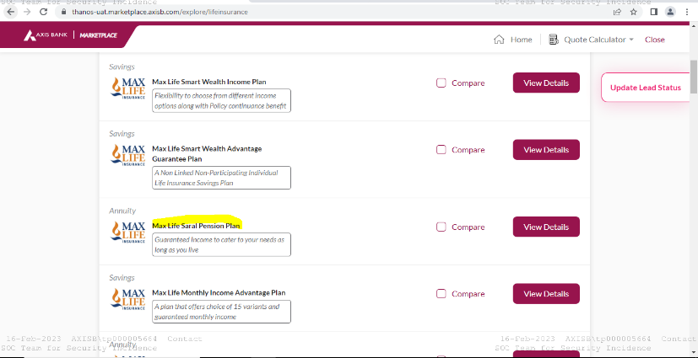
Redirected on mSales: Saral Pension Plan is reflecting
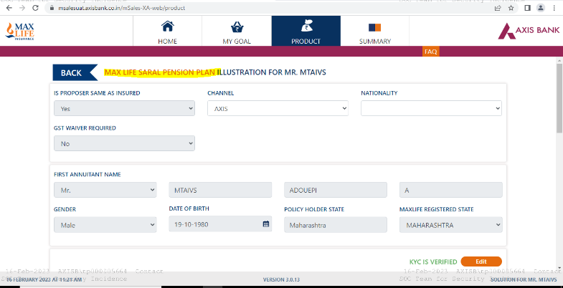
On MLI CRM- Saral Pension Plan is reflecting
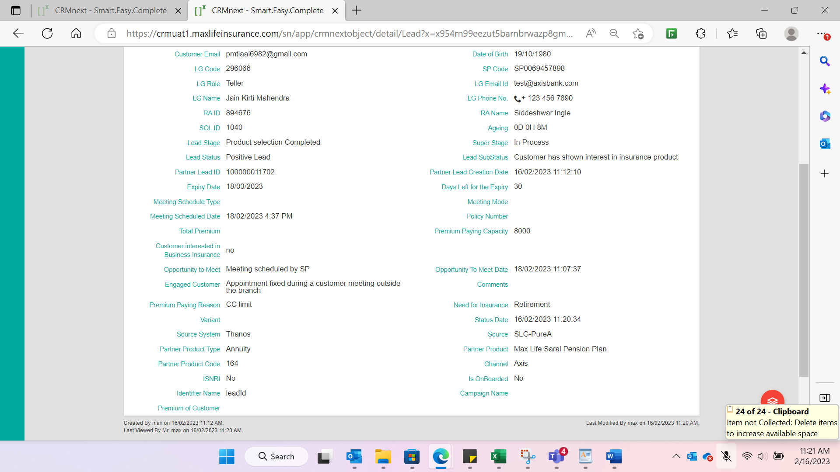

- On Same Stage- Product Selection Completed, Updating Plan from Thanos/AMP
Updated plan- Max Life Monthly Income Advantage Plan
Till here no update done by SP&RA
THANOS
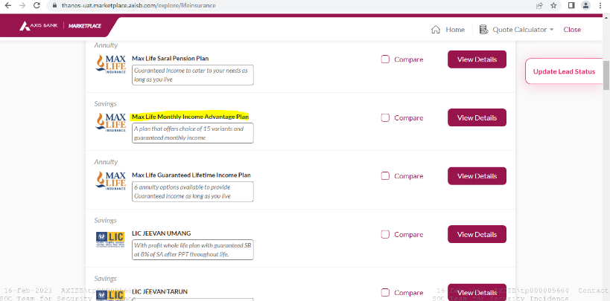
Redirected on mSales with updated Monthly Income Advantage Plan
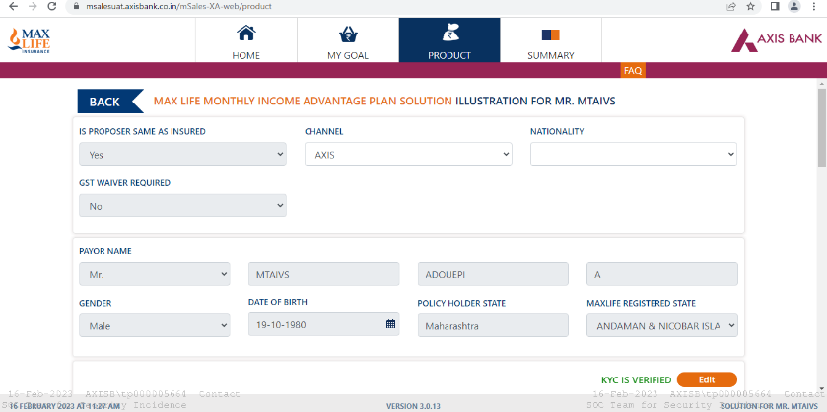
Updated Monthly Income Advantage Plan is reflecting on MLI CRM
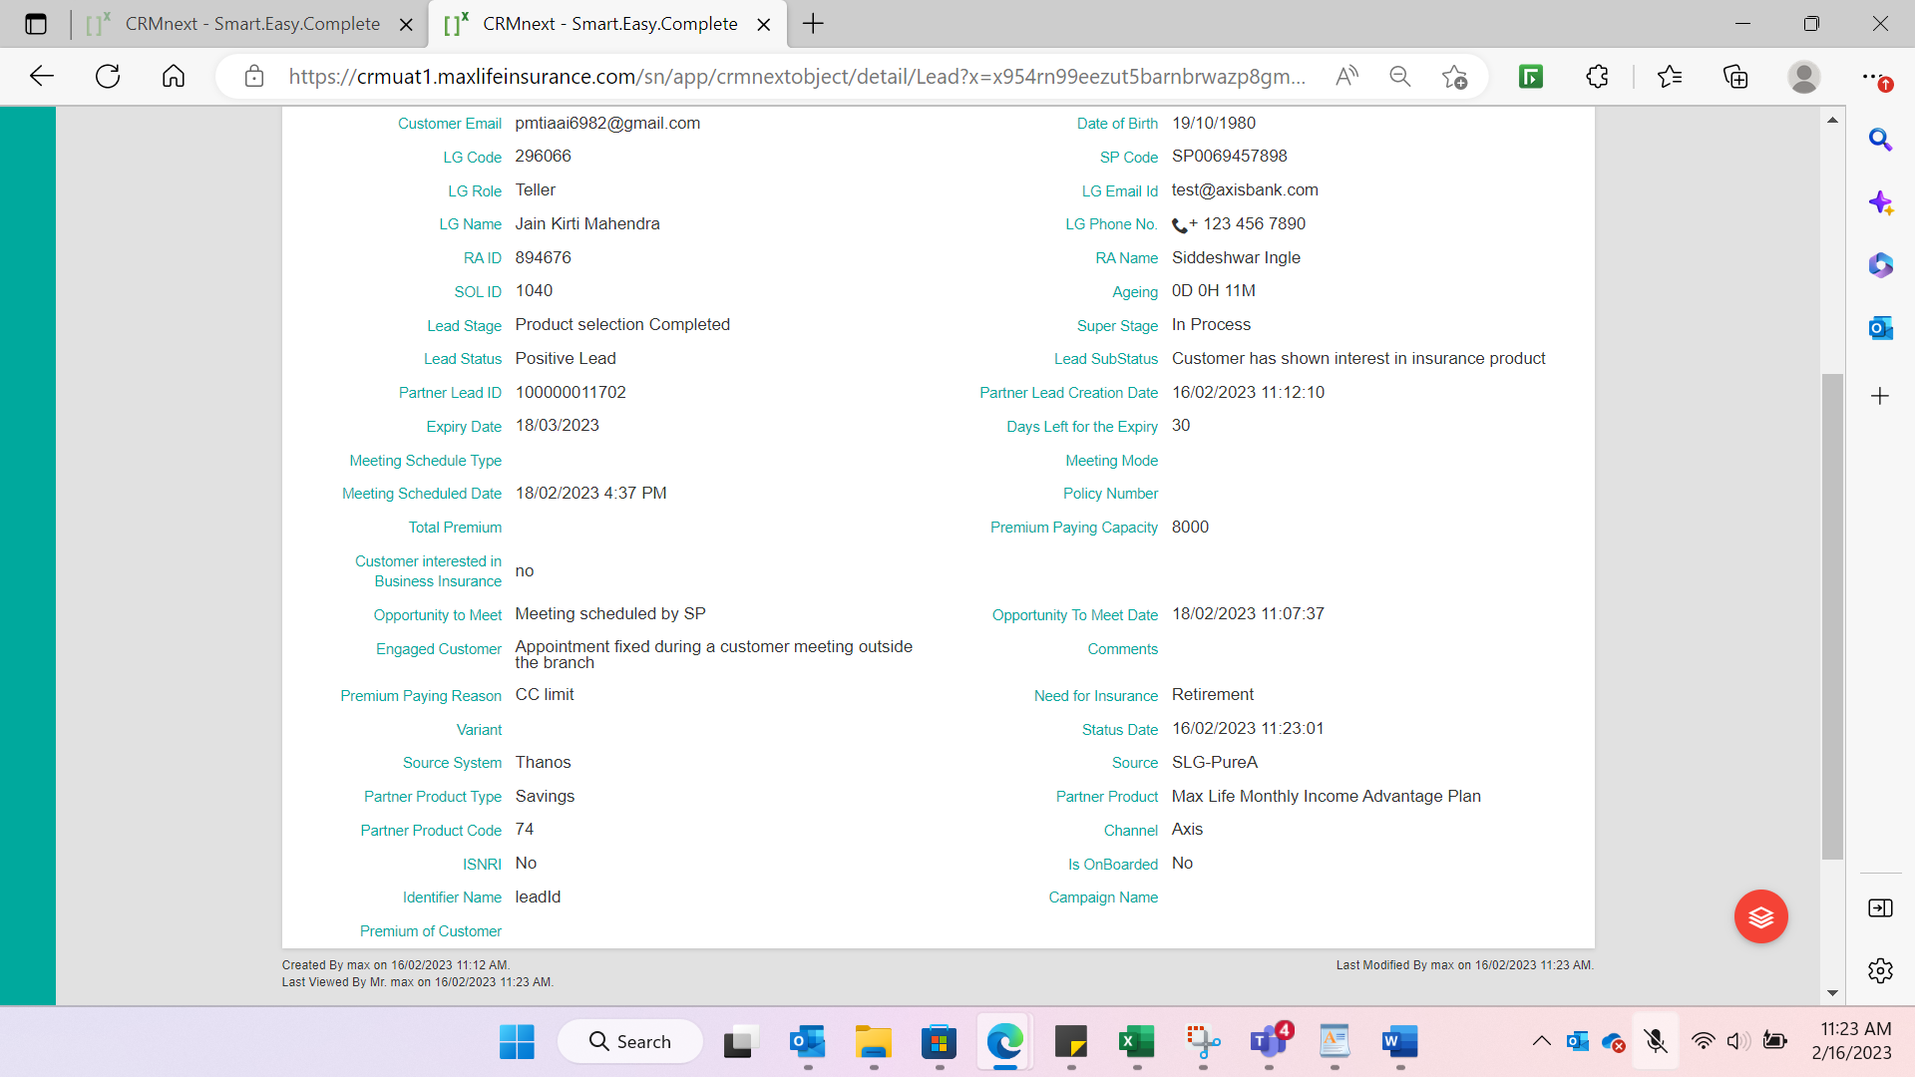
- Stage- Product Selection Completed
Plan- Max Life Monthly Income Advantage Plan
Now Updating disposition status on MLI CRM from
Follow up Meeting schedule to Follow up Customer Busy
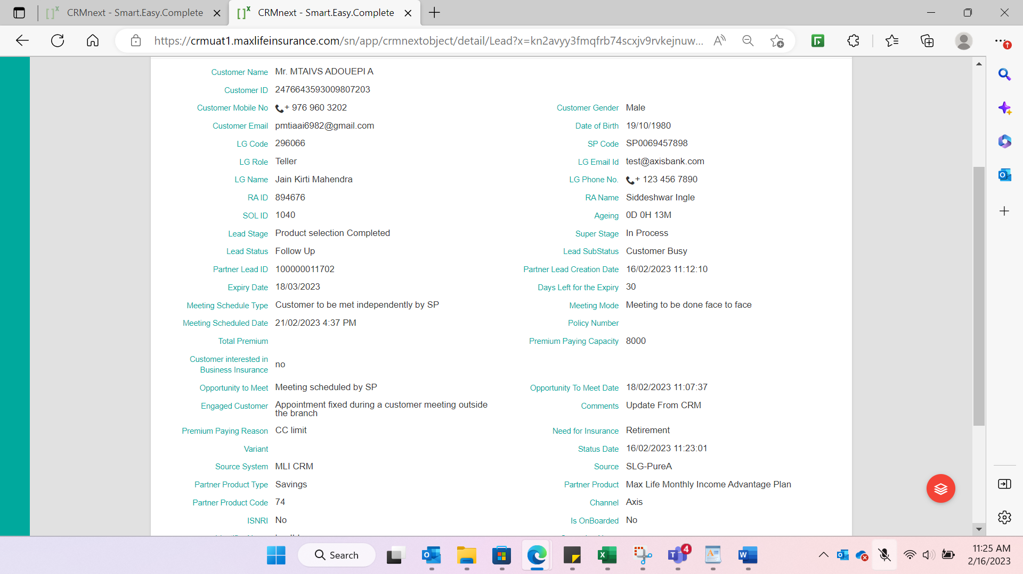

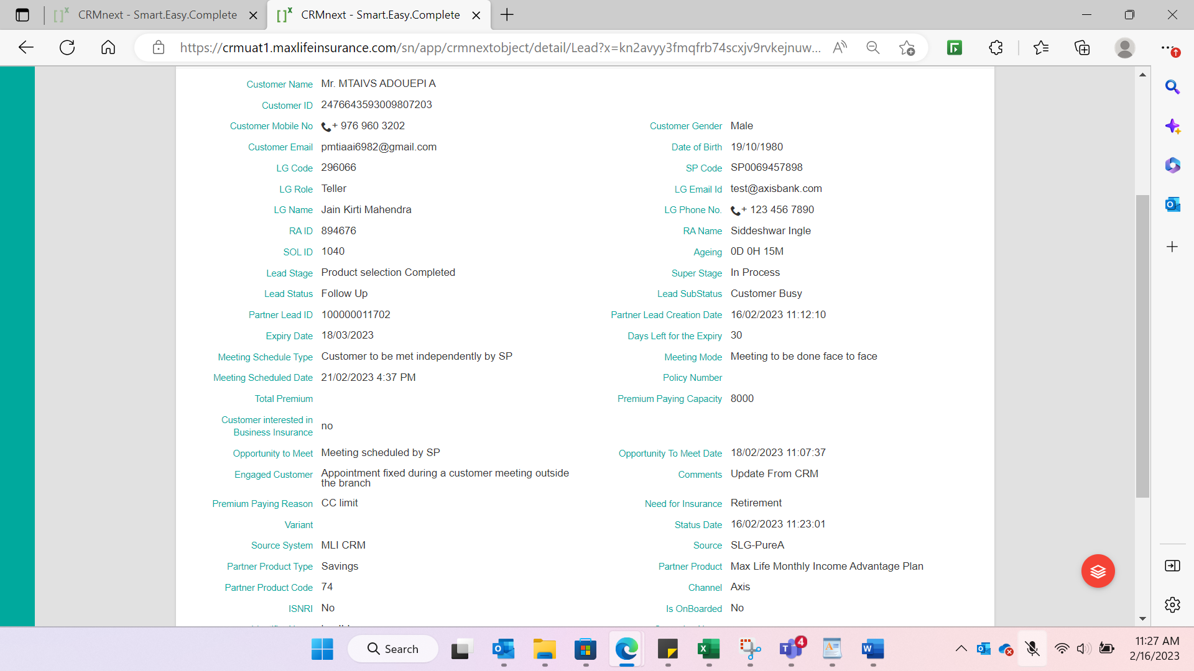
Updates reflecting on Thanos
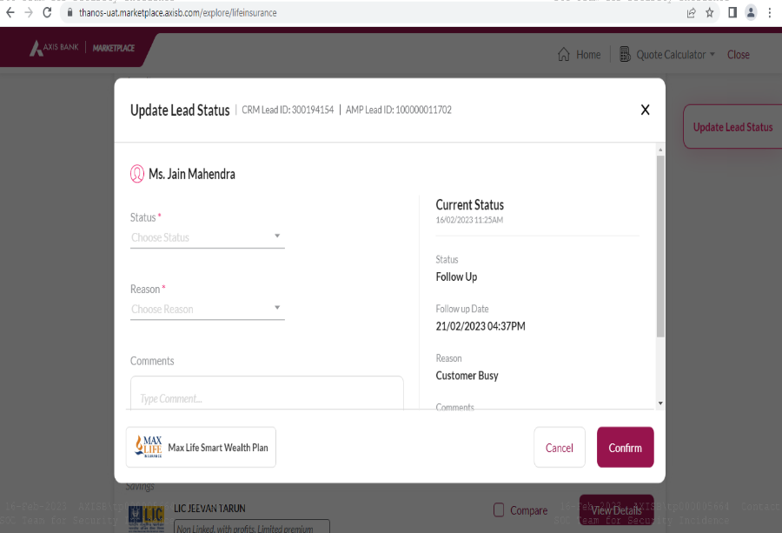

- Now trying to update Product from Thanos on Product Selection Completed Stage
Updating product with Max Life Smart Secure Easy Solution
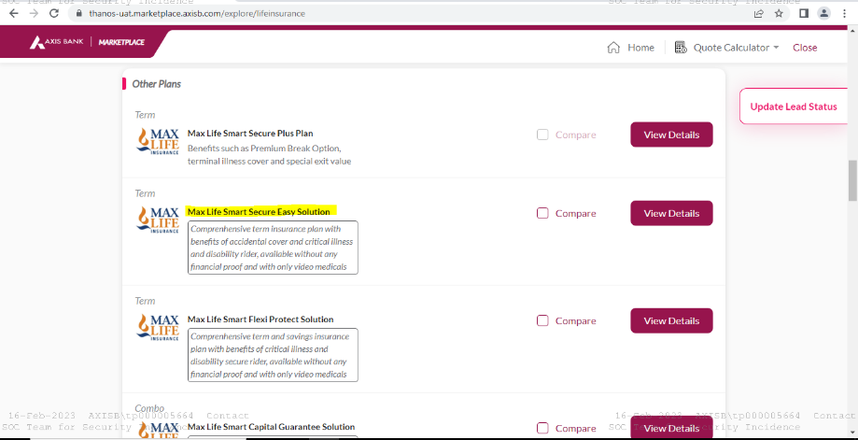

Redirecting on mSales with previous plan i.e. Max Life Monthly Income Advantage Plan
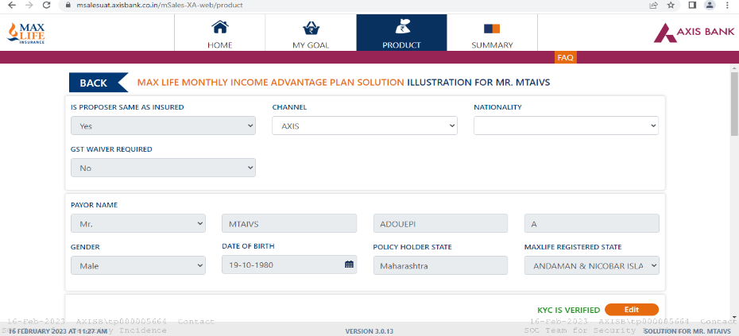
Also not getting updated plan on MLI CRM
